Using technology with low level ESL students? How hard could it be?
My first stint at a community college was teaching an ESL class of preliterate students. I was assigned to take my class to use the computer lab once a week. I had not taken ESL students to a computer lab before and I was excited. I had visions of how the multimedia interface would be so much more interesting than black and white handouts and rote classroom activities. My plan was to go into the lab, ask the students to log into the computers and try out some interactive TPR software. This was going to be fun! I was calm, I was prepared. Or so I thought…
Using technology with low level ESL students? Are you crazy?
“Okay everyone, log in.”
As if! I spent the first hour running franticly from one student to another, shouting “Control Alt Delete!” and “Two hands at the same time! left click, no left click, no left, left, left, left, click, click ONCE, left click ONE TIME. NO type NO stop NO STOP!”
For the second week I had a brainstorm. I prepared overhead projector sheets with pictures of the keyboard highlighting the Ctrl + Alt + Delete keys with which I demonstrated in advance how to get the login window to pop up. I was sure I had solved my problem; students would see what I was talking about and we could go into the lab and log in without delay.
Wrong. I still spent the first hour trying to log all the students in to their computers. The user name box called for a full student name and the password was set for a 9 digit student ID number. Most students were struggling to find the right the keys on the keyboard. On top of this, the log in windows were set to time out if you took too long typing all that information in. So, many of the students would get part of their ID number entered, the screen would suddenly blink and they would be back at the beginning starting with Ctrl+Alt+Delete.
It took me until the end of the first quarter to convince the IT department to give my class its own login window, one that had a very simple user name (Student) and password that the class shared (English). This allowed us to actually login and still have time to use the computers. However, similar problems reemerged with students interacting with software; English did not seem to be the issue, and I could not quite put my finger on what was. I began to have serious second thoughts about the value of taking students to the lab.
Lessons learned from Pre-literacy studies
As I examined the challenges I was having in the lab I noticed that some of what I had learned about teaching English to learners not literate in their first language might apply to teaching technology. For example, in a Level One ESL classroom an instructor might give a student a handout and assume this student will know to write her/his name on the appropriate line at the top. In preliterate classrooms it cannot be assumed that the student will even assign significance to the line at the top. Preliterate instructors learn to explicitly teach learners to see lines on paper as objects with which they are supposed interact in prescribed ways. This holds true for the concepts of left/right or understanding check boxes. It occurred to me that maybe I needed to back up a few steps and allow my students to interact with a login page one piece at a time. There are so many little things that I assume make sense; what a user name means, what the purpose of a password is, what does it mean when those black dots appear instead of the password being typed on the keyboard. And, I might have to teach things that I might have incorrectly assumed students already understood. I am not just asking them to use the “control-alt-delete” keys. I am asking them to use two fingers on their left hand and one finger on their right hand, to locate, press and hold down those three keys at the same time and then let them go when the pop up window appears.
Groundhog Day
Once I realized this it became clear to me that students were not getting enough regular exposure to technology. Going to the lab once a week was not enough. I was asking them to use their hands in ways they were not used to and to become familiar with new concepts without frequent enough repetition to build dexterity or memory. The knowledge and skills seemed to stay only in short term memory, and thus needed to be reintroduced every week.
Going to the computer lab once a week with my low level ESL students began to resemble the plot line from the movie Groundhog Day. In this movie the main character (Bill Murray) wakes up morning after morning to relive the exact same frustrating day over and over again. He always seems to remember just enough about the previously lived day to know that he needs to do a few things differently but he can’t quite remember in time to prevent repeating the same sad mistakes. One day a week in the computer lab is just Day One over and over again. “Ctrl Alt Delete! Left, no Left click, click!”
Mirroring activities in the F2F classroom
Armed with the idea that my students needed more focused and discrete practice, my next challenge became offering opportunities to do so given the limited availability of computer lab time at my institution. Again, calling upon what I had learned about working with literacy students, I remembered that it helped to think in a conceptual way about the smaller almost invisible skills and concepts students might need to develop and understand. What are those things and is there a way to isolate them and offer opportunities in the face to face (F2F) classroom? One of the literacy strategies for teaching the alphabet is to provide letters formed with sandpaper for students to feel the shape of a letter before they attempt to use new muscles holding a pencil to write the letter. I applied this idea to learning to use a mouse to click on web pages. I had watched students struggle isolating the muscles needed to move their index finger on a mouse button. I set out to create a list of activities in which I could have students use their index finger to tap as a way of indicating they were selecting something. I ask students to respond in a manner that requires the same muscle skill they need for using a mouse. For example, I ask students to select a picture at their table by tapping on it with their index finger (using the dominant or mousing hand) and then double tap on a corresponding alphabet letter or word. What I found as I gathered and created activity ideas, was that in addition to providing an opportunity for building skills and memory, the F2F classroom offers a less distracting environment than the computer lab. In some ways, learning these things first in a controlled atomosphere where the affective filter was lower, proved to be a superior method over throwing them in the computer lab to be overwhelmed by speed and visual stimuli.
How to map this out
As I began to get excited again about taking students to the computer lab I realized that it was also a priority that that I not overload myself with additional prep time. What I wanted was to use my prep time more effectively. I came up with a grid (see below) to help myself think ahead about what kinds of skills/concepts students would need in the lab. For every project or task I assign students in the computer lab, I use this grid to lay out the invisible steps so that I can build them into my lesson plans right from the beginning of the quarter. That way I can double load my activities in the F2F classroom. If I usually have students raise their hands to indicate an answer I could substitute the handraising with something that would build technology skill (like tapping). Because I have thought ahead about how saving a document on a computer requires the conceptual understanding of a filing system, I have students create file folders on day one and have them interact with them by saving their work in those folders.
The grid is very straightforward: I put the target task we are going to do in the lab in the first column. Then I break down the skills and concepts that students may need to learn. I assess students to find the gaps and then list activities in the second column that I will use in the F2F classroom to build a foundation. The final column is where I list activities that they can do in the computer lab to build the same skills and concepts.
Task | Skills/Concepts | F2F activity | Computer Lab
Log In | What is the page asking you to do?  - User Name  - Password  White space vs. lines and boxes  Keyboard | Talk about names, nicknames, keys and locks, other concepts that students are already familiar with. Have students create user names and passwords that they have to produce in writing. E.g. your attendance sheet could require a user name and “password”.  Practice with paper forms cut up into separate pieces  Capital and lowercase letters, how are they different | Simple log in pages (make your own) advanced ss sign up for Gmail, and yahoo  Simple websites with boxes and lines  Practice using shift key

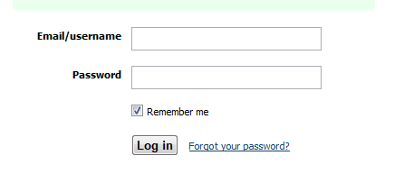 | 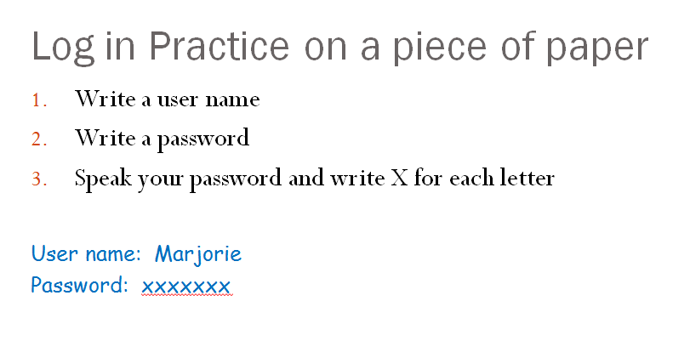

It is worth noting that in the process of creating my grids I have often unearthed hidden complexity. I thought that creating a Word document would be a simple rote task. As you can see below, it requires a lot of conceptual skill. I have also found it helpful to build in a practice round with each set of students to identify specific skill/knowledge gaps.
Task | Skills/concepts needed | F2F | Computer Lab
Using Microsoft Word | Icon recognition  Double clicking  Filing systems and naming protocols  Navigating a window and menus  Open/New/Save | Pictures of a large Blue W  --Single tapping as a way of responding  --Double tapping as a different response  Use file folders and a filing system every day in the classroom as a way that students name, alphabetize, store and retrieve their own papers.  ________________  ________________  ________________  ________________ | Open Word  --Listening to the click  --Feeling the click  --Watching what happens when you click and double click  Saving a document with a name and finding it again.  ________________  ________________  ________________  ________________

Can low level ESL students learn 21st century skills using technology? Yes!
In conclusion I want to say that when I started out exploring technology I thought that any use of computers would be helpful to my students. I have since discovered the value of creating opportunities in which the learners get to be explorers and creators in technology. Daniel Pink suggests in his book Drive, that self-direction and creativity, are 21st century skills. Beyond teaching students how to point and click using expensive software packages that they will never use outside the classroom, I think it is worth exploring what we call Web 2.0 tools that provide opportunities for even low level ESL students to interact with technology in ways that will empower them outside of the classroom. The above suggestions for teaching skills in the F2F classroom apply quite well with these new programs. To this end, I also build in F2F activities that engage students in collaborative learning; writing together on a portable whiteboard or simply a shared piece of paper. This way when we move to the computer lab to work with websites where students can write or draw on each other’s work, they are already familiar with the concept. VoiceThread is an example of a powerful, interactive, learning website. Screen capture tools such as Jing and virtual whiteboards like Fooboard are all examples of learning tools that can be used for collaborative and creative learning. I firmly believe that with a little scaffolding, all levels of ESL students can learn to use technology and in the process become empowered agents of their own learning.
REFERENCES
Hughes, B. (2007). Technology and Equity: Moving beyond access to addressing causal factors
Kucukaydin, I., Tisdell, E. (2008). The discourse on the digital divide: Are we being co-opted? InterActions: UCLA Journal of Education and Information Studies, 4(1).
Pink, D. (2009) Drive, The Surprising Truth About What Motivates Us. Riverhead Books, N.Y.
Silver-Pacuilla, H., Fleischman, S., (2006). Technology to help struggling students. Educational Leadership, 85
Silver-Pacuilla, H. (2008). Investigating the Language and Literacy Skills Required for Independent Online Learning: National Institute for Literacy.
Simms, J., and Knowlton, D. S. (2008). Ideas in practice: Instructional design and delivery for adult learners Developmental Education, 32(1).

